Chapter 7, Solution 74.

Let v = capacitor voltage. For t < 0, 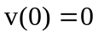
For t > 0, 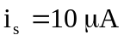.
i_{s}
50 kΩ
−
+
10 kΩ
2 µF
+
v_{o}
−
i_{s}

Since the current through the feedback resistor is i_{s}, then

v_{o} = –i_{s}x10⁴ volts = –10^{–5}x10⁴ = –100 mV.

It is interesting to look at the capacitor voltage.

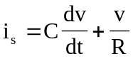
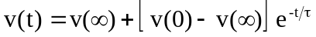

It is evident that

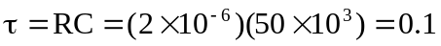

At steady state, the capacitor acts like an open circuit so that passes through R. Hence,

Then the voltage across the capacitor is,

v(t) = 500(1–e^{–10t}) mV.

